4.Give your answers for the questions given at the end of exercise in a word file. (attach screenshots of the dashboard depicting the answers)

1. What is the emissions per capita of Canada?

Ans. 17.72

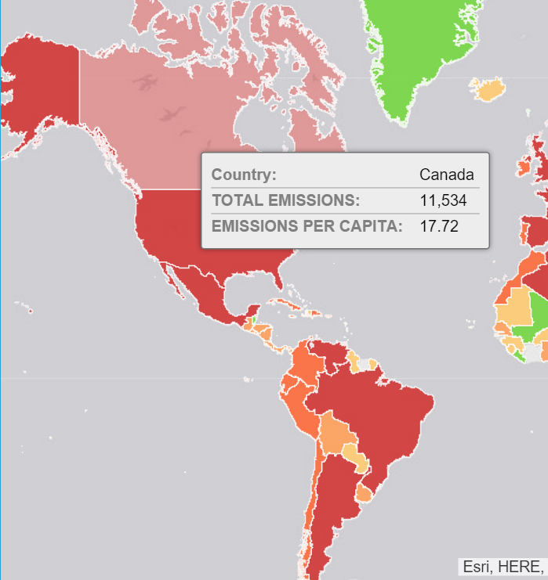

2. What is the overall trend in worldwide emissions?

Ans. Overall trend is worldwide emissions is increasing except in 2009 when it declined.

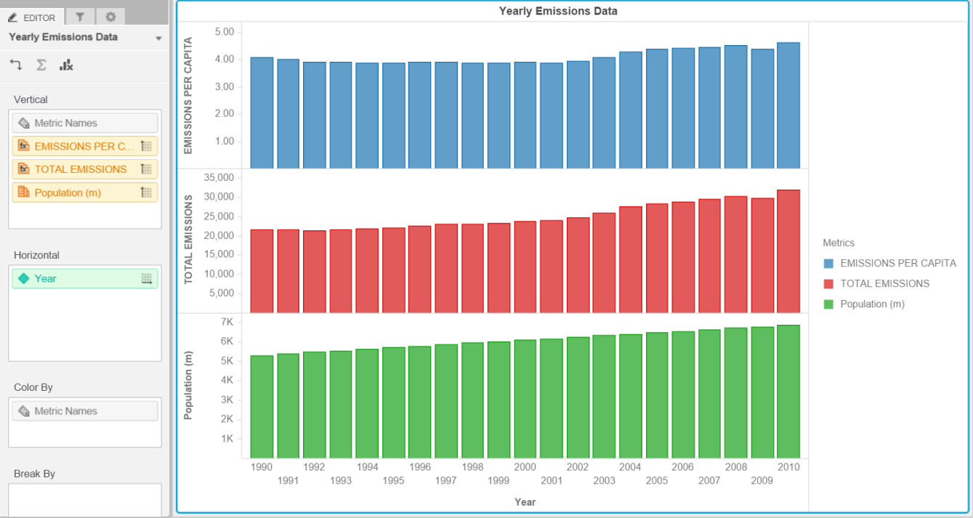

3. Notice that overall emissions declined in 2009, the only year in the total number of years surveyed that indicates emissions decreases in all three emissions sources. Why is that? What broader socio-political context might explain this single yearly decrease?

Ans. Due to world economic recession in 2009.

